Министерство образования Республики Беларусь

Учреждение образования

БЕЛОРУССКИЙ ГОСУДАРСТВЕННЫЙ УНИВЕРСИТЕТ

ИНФОРМАТИКИ И РАДИОЭЛЕКТРОНИКИ

Факультет компьютерных систем и сетей

Кафедра электронных вычислительных машин

Лабораторная работа № 1

«Структура программы на Си. Функции ввода-вывода»

Проверил: Выполнил:   
Богдан Е.В. Бекетова М.А.

МИНСК 2022

**Задача 1**

1. Ввести высоту и радиус цилиндра. Найти площадь боковой поверхности, площадь полной поверхности и объем цилиндра. Результат вывести с точностью до двух знаков после запятой.

Блок-схема:

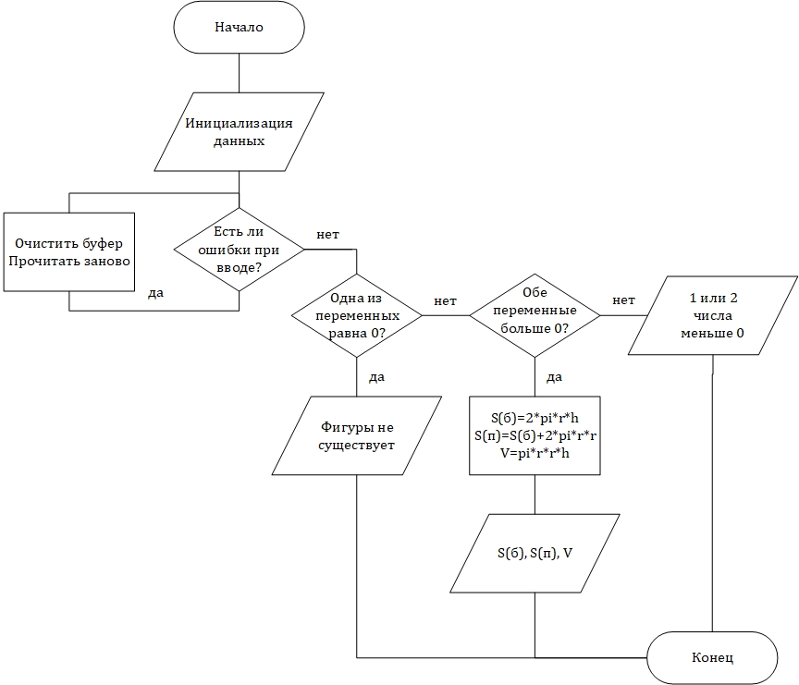

Код программы:

void zadacha1()

{

int r, h;

double pi = 3.14159265; //задание числа пи без использования мат.библиотеки

printf("Enter r, h\n");

while (scanf_s("%i%i", &r, &h) != 2) //проверка на ввод

{

while (getchar() != '\n')

continue;

printf("Oops... Wrong input, try again\n");

}

if ((r == 0) || (h == 0)) //при равенстве одной из переменных нулю

{

printf("Are you sure?.. Figure does not exist\v");

return;

}

else if (r > 0 && h > 0)

{

double S_side = 2 * pi * r * h;

double S_total = S_side + 2 * pi * r * r;

double V = pi * r * r * h;

printf("S(side)=%.2lf, S(total)=%.2lf, V=%.2lf\n", S_side, S_total, V);

return;

}

else //при вводе 1 или 2 отрицательных чисел

{

printf("Oops... 1 or 2 of the numbers are negative\n");

return;

}

}

Тестирование программы:

|  |  |  |  |
| --- | --- | --- | --- |
| № теста | Вводимые данные | Ожидаемый результат | Полученный результат |
| 1 | 3 3f | Oops... Wrong input, try again | Oops... Wrong input, try again |
| 2 | 3f | Oops... Wrong input, try again | Oops... Wrong input, try again |
| 3 | 0  33 | Are you sure?.. Figure does not exist | Are you sure?.. Figure does not exist |
| 4 | 33  0 | Are you sure?.. Figure does not exist | Are you sure?.. Figure does not exist |
| 5 | -33  3 | Oops... 1 or 2 of the numbers are negative | Oops... 1 or 2 of the numbers are negative |
| 6 | 33  -3 | Oops... 1 or 2 of the numbers are negative | Oops... 1 or 2 of the numbers are negative |
| 7 | 33  3 | S(side)=622.04, S(total)=7464.42,  V=10263.58 | S(side)=622.04, S(total)=7464.42,  V=10263.58 |
| 8 | 3  33 | S(side)=622.04, S(total)=678.58, V=933.05 | S(side)=622.04, S(total)=678.58, V=933.05 |

**Задача 2**

1. Даны два числа a и b. Определите, равны или не равны эти числа.

Блок-схема:

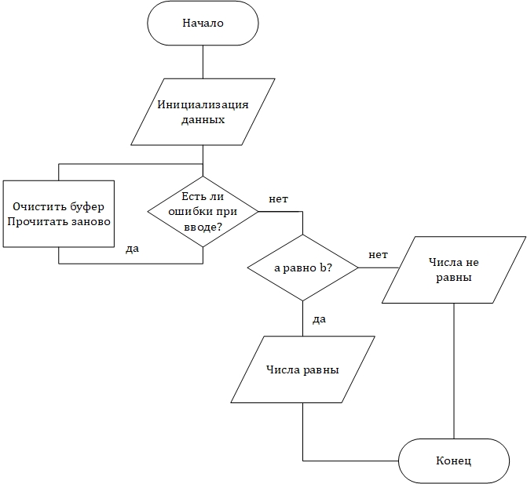

Код программы:

void zadacha2()

{

float a, b;

printf("Enter a, b\n");

while (scanf_s("%f%f", &a, &b) != 2) //проверка на ввод

{

while (getchar() != '\n')

continue;

printf("Just.enter.2.numbers...\n ");

}

if (a == b)

printf("Numbers are the same\v");

else

printf("Oh, numbers are not the same, bye-bye!\v");

}

Тестирование программы:

|  |  |  |  |
| --- | --- | --- | --- |
| № теста | Вводимые данные | Ожидаемый результат | Полученный результат |
| 1 | 7 7f | Just.enter.2.numbers... | Just.enter.2.numbers... |
| 2 | 7f | Just.enter.2.numbers... | Just.enter.2.numbers... |
| 3 | 7  77 | Oh, numbers are not the same, bye-bye! | Oh, numbers are not the same, bye-bye! |
| 4 | -3  7 | Oh, numbers are not the same, bye-bye! | Oh, numbers are not the same, bye-bye! |
| 5 | -7  -33.3 | Oh, numbers are not the same, bye-bye! | Oh, numbers are not the same, bye-bye! |
| 6 | 7.0  7 | Numbers are the same | Numbers are the same |
| 7 | 3.3  3.3 | Numbers are the same | Numbers are the same |
| 8 | -5  -5 | Numbers are the same | Numbers are the same |

**Задача 3**

1. Если среди чисел a, b и c есть пара взаимно противоположных, вывести третье (оставшееся) число, в противоположном случае вывести сообщение "нет".

Блок-схема:

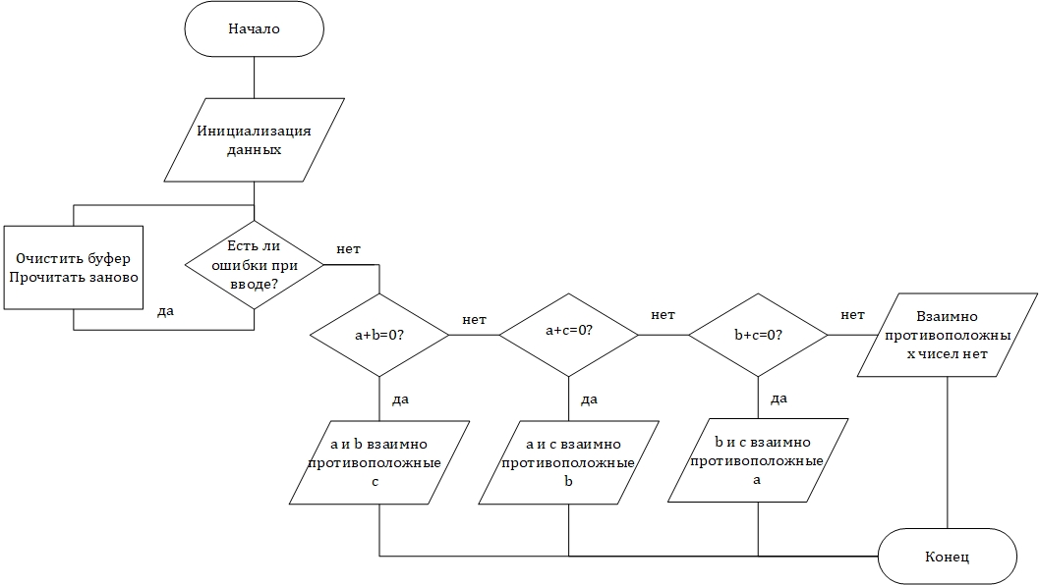

Код программы:

void zadacha3()

{

float a, b, c;

printf("Enter a, b, c\n");

while (scanf_s("%f%f%f", &a, &b, &c) != 3)//проверка на ввод

{

while (getchar() != '\n')

continue;

printf("Is it so hard to enter just numbers? Try again, now.\n");

}

if (a + b == 0)

printf("Those two (a and b) turned into 0, so only c=%f survived\v", c);

else if (a + c == 0)

printf("Those two (a and c) turned into 0, so only b=%f survived\v", b);

else if (b + c == 0)

printf("Those two (b and c) turned into 0, so only a=%f survived\v", a);

else

printf("No. None of the pairs of numbers is mutually opposite\v");

}

Тестирование программы:

|  |  |  |  |
| --- | --- | --- | --- |
| № теста | Вводимые данные | Ожидаемый результат | Полученный результат |
| 1 | 3 4 5f | Is it so hard to enter just numbers? Try again, now. | Is it so hard to enter just numbers? Try again, now. |
| 2 | 1 -1 3 | Those two (a and b) turned into 0, so only c=3.000000 survived | Those two (a and b) turned into 0, so only c=3.000000 survived |
| 3 | 3 1 -1 | Those two (b and c) turned into 0, so only a=3.000000 survived | Those two (b and c) turned into 0, so only a=3.000000 survived |
| 4 | 1 3 -1 | Those two (a and c) turned into 0, so only b=3.000000 survived | Those two (a and c) turned into 0, so only b=3.000000 survived |
| 5 | 3.3 -3.3 5 | Those two (a and b) turned into 0, so only c=5.000000 survived | Those two (a and b) turned into 0, so only c=5.000000 survived |
| 6 | 34 45 56 | No. None of the pairs of numbers is mutually opposite | No. None of the pairs of numbers is mutually opposite |

**Задача 4**

1. По номеру месяца напечатать его название.

Блок-схема:

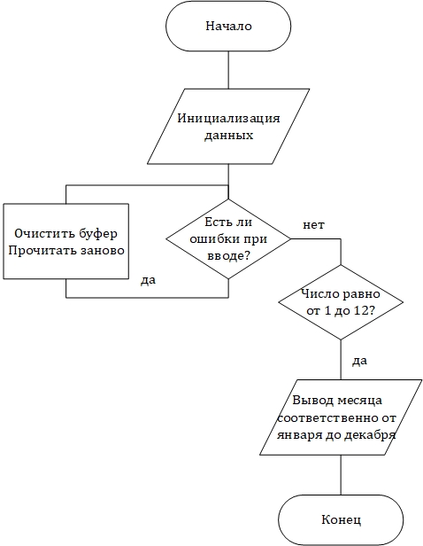

Код программы:

void zadacha4()

{

int a;

printf("Enter the month number in the form '1', '5', '11' etc.\n");

while (!scanf_s("%d", &a) || a < 1 || a >12) //проверка на ввод

{

while (getchar() != '\n')

continue;

printf("Again, put the month number here\n");

}

if (a == 1)

printf("Month: January (Winter) P.S. Happy New Year!!!\v");

if (a == 2)

printf("Month: February (Winter)\v");

if (a == 3)

printf("Month: March (Spring)\v");

if (a == 4)

printf("Month: April (Spring)\v");

if (a == 5)

printf("Month: May (Spring)\v");

if (a == 6)

printf("Month: June (Summer)\v");

if (a == 7)

printf("Month: July (Summer)\v");

if (a == 8)

printf("Month: August (Summer)\v");

if (a == 9)

printf("Month: September (Autumn)\v");

if (a == 10)

printf("Month: October (Autumn)\v");

if (a == 11)

printf("Month: November (Autumn)\v");

if (a == 12)

printf("Month: December (Autumn)\v");

}

Тестирование программы:

|  |  |  |  |
| --- | --- | --- | --- |
| № теста | Вводимые данные | Ожидаемый результат | Полученный результат |
| 1 | 3f | Again, put the month number here | Again, put the month number here |
| 2 | 4.5 | Again, put the month number here | Again, put the month number here |
| 3 | 1 | Month: January (Winter) P.S. Happy New Year!!! | Month: January (Winter) P.S. Happy New Year!!! |
| 4 | 6 | Month: June (Summer) | Month: June (Summer) |

**Приложение 1**

Алгоритм выбора задачи:

